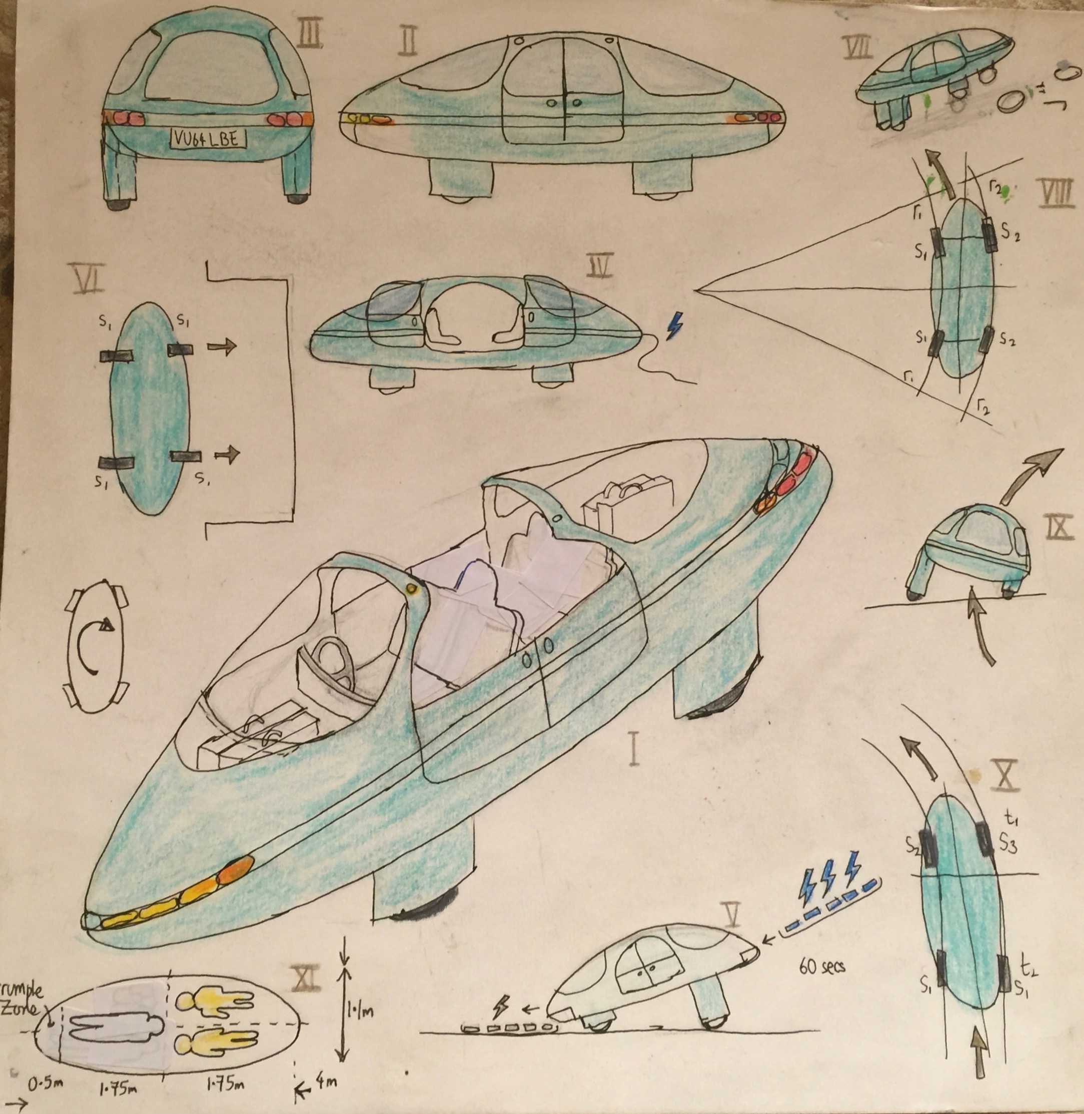Klima Ko-op

16-17 Jan 2016

Peer Review Minutes

Attendees: Robert Bowerman, David Bowerman, Alastair Bowerman, Alexander Paul Bowerman, Niel Bowerman and Zhenya Kazlou.

Apologies: Greg Colbourn, Ian Pinder, Anthony Bowerman

Location: Badgers Cottage, Worley, Nailsworth, Stroud, GL6 0RD

1. Robert walked attendees through the presentation held on the tool prezi.com. The team walked through about the first third of the presentation, so there is more to see. See the following link <http://prezi.com/zvf81wvyt1qm/?utm_campaign=share&utm_medium=copy>
2. The gently building repository of the design is at GitHub.